**Introduction to Robots – Assignment 2**

Question 1: what is the definition of robot

A robot is a type of automated machine that can execute specific tasks with little or no human intervention and with speed and precision. The field of robotics, which deals with robot design, engineering and operation, has advanced remarkably in the last 50 years.

IDC identifies robotics as one of six innovation accelerators driving [digital transformation](https://www.techtarget.com/searchcio/definition/digital-transformation). The others include [3D printing](https://www.techtarget.com/whatis/definition/3-D-printing-rapid-prototyping-stereolighography-or-architectural-modeling), [cognitive computing](https://www.techtarget.com/searchenterpriseai/definition/cognitive-computing), [next-generation security](https://www.techtarget.com/searchsecurity/tip/SOC-20-Three-key-steps-toward-the-next-generation-security-operations-center) and [virtual reality](https://www.techtarget.com/whatis/definition/virtual-reality) or [augmented reality](https://www.techtarget.com/whatis/definition/augmented-reality-AR).

**What can robots do?**

Essentially, there are as many different types of robots as there are tasks for them to perform. Robots can perform some tasks better than humans, but others are best left to people and not machines.

The following are things robots do better than humans:

* Automate manual or repetitive activities in corporate or industrial settings.
* Work in unpredictable or hazardous environments to spot hazards like gas leaks.
* Process and deliver reports for enterprise security.
* Fill out pharmaceutical prescriptions and prep IVs.
* Deliver online orders, room service and even food packets during emergencies.
* Assist during surgeries.
* Robots can also make music, monitor shorelines for dangerous predators, help with search and rescue and even assist with food preparation.

Despite their increasing ubiquity, there are several shortcomings to using robots.

They can, for example:

* perform surgeries but not soothe scared patients;
* sense furtive footsteps in a closed-off area, but not take action against gate-crashers;
* lead exercise sessions for the elderly but not ease their loneliness;
* help medical professionals with diagnoses, but not empathize with patients; and
* learn from data, but not correctly respond to unexpected situations.

The increasingly complex capabilities of robots will eventually eliminate some human tasks, but not all. Current robotics technology can automate only [25% of tasks](https://www.mckinsey.com/~/media/mckinsey/featured%20insights/Digital%20Disruption/Harnessing%20automation%20for%20a%20future%20that%20works/MGI-A-future-that-works-Executive-summary.ashx) in unpredictable, human-dependent areas like construction and nursing. But robots depend on human programming -- and they (likely) always will.

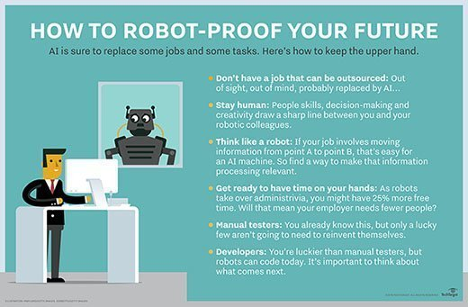

### Types of robots

There are as many different types of robots as there are tasks.

#### 1. Androids

Androids are robots that resemble humans. They are often mobile, moving around on wheels or a track drive. According to the American Society of Mechanical Engineers, these [humanoid robots are used in areas](https://www.asme.org/topics-resources/content/10-humanoid-robots-of-2020) such as caregiving and personal assistance, search and rescue, space exploration and research, entertainment and education, public relations and healthcare, and  manufacturing. As use cases and applications explode, the android market is poised to hit $13 billion by 2026.

#### 2. Telechir

A telechir is a complex robot that is remotely controlled by a human operator for a telepresence system. It gives that individual the sense of being on location in a remote, dangerous or alien environment, and enables them to interact with it since the telechir continuously provides sensory feedback.

#### 3. Telepresence robot

A [telepresence robot](https://www.techtarget.com/searchenterpriseai/definition/telepresence-robot) simulates the experience -- and some capabilities -- of being physically present at a location. It combines remote monitoring and control via telemetry sent over radio, wires or optical fibers, and enables remote business consultations, healthcare, home monitoring, childcare and more.

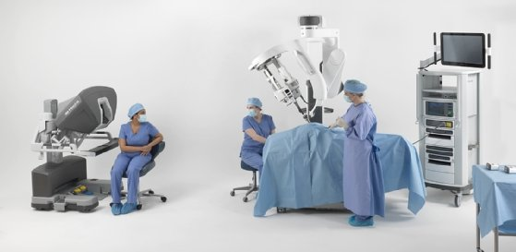

#### 4. Industrial robot

The IFR (International Federation of Robotics) [defines](https://ifr.org/industrial-robots) an industrial robot as an "automatically controlled, reprogrammable multipurpose manipulator programmable in three or more axes." Users can adapt these robots to different applications as well. Combining these robots with AI has helped businesses move them [beyond simple automation to higher-level and more complex tasks](https://www.techtarget.com/searchenterpriseai/feature/Application-of-AI-in-robotics-boosts-enterprise-potential).

In 2019, there were over 390,000 industrial robots installed worldwide, according to the IFR -- with China, Japan and the U.S. leading the way.

In industrial settings, such robots can do the following:

* optimize process performance;
* automate production to increase productivity and efficiency;
* speed up product development;
* enhance safety; and
* lower costs.

#### 5. Swarm robot

[Swarm robots](https://www.techtarget.com/searchenterpriseai/definition/swarm-robotics) (aka insect robots) work in fleets ranging from a few to thousands, all under the supervision of a single controller. These robots are analogous to insect colonies, in that they exhibit simple behaviors individually, but demonstrate behaviors that are more sophisticated with an ability to carry out complex tasks in total.

#### 6. Smart robot

This is the most advanced kind of robot. The smart robot has a built-in AI system that learns from its environment and experiences to build knowledge and enhance capabilities to continuously improve. A smart robot can collaborate with humans and help solve problems in areas like the following:

* agricultural labor shortages;
* food waste;
* study of marine ecosystems;
* product organization in warehouses; and
* clearing of debris from disaster zones.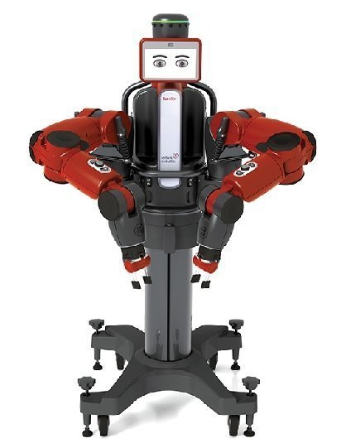

**Common characteristics of robots**

Not all robots look like HAL 9000 in *2001: A Space Odyssey* or Big Dog -- a rough-terrain quadruped robot with complex sensors, gyroscopes and [hydraulic](https://www.techtarget.com/whatis/definition/hydraulics) actuators -- from [Boston Dynamics](https://www.techtarget.com/whatis/definition/Boston-Dynamics). Some have human-like features (androids), while others are all mechanical limbs (Packo). Still others look like keychains (Tamagotchi) or whizzing toys (Roomba).

Nonetheless, all robots have some common characteristics, such as the following:

* mechanical construction
* electrical components
* computer programming

As AI and software advance, robots will become smarter, more efficient and will take on more complex challenges.

**Robotic process automation and intelligent process automation**

Robotic process automation ([RPA](https://www.techtarget.com/searchcio/definition/RPA)) technology involves the design, deployment and use of software-based robots to accomplish things like the following:

* automate rules-based business processes;
* streamline enterprise operations;
* save human effort; and
* lower costs.

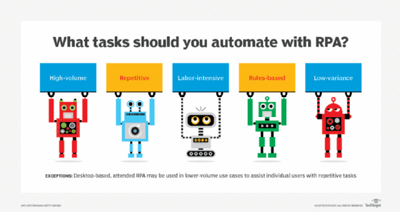

RPA automates repetitive tasks so human personnel can focus on higher-value work. Use cases can be simple (automated email responses) or complex (automating thousands of jobs).

RPA is a steppingstone to more advanced intelligent process automation ([IPA](https://www.techtarget.com/searchenterpriseai/definition/intelligent-process-automation-IPA)). IPA adds decision-making capabilities, AI tools and cognitive technologies like [natural language processing](https://www.techtarget.com/searchenterpriseai/definition/natural-language-processing-NLP) and [machine learning](https://www.techtarget.com/searchenterpriseai/definition/machine-learning-ML).

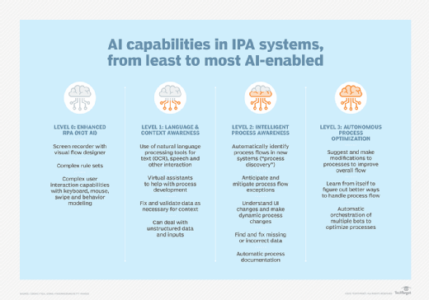

### Robots and robotics: A short history

The 1921 play, R.U.R., which stands for Rossum's Universal Robots, by Czech writer Karel Capek, first introduced the word "robot." These robots were artificial people rather than machines, and could think for themselves, so they are somewhat similar to modern androids. Isaac Asimov said that Capek contributed the word robot to all languages in which science fiction is written. Asimov introduced the word robotics and his famous Three Laws of Robotics in his story "Runaround."

The first robots, although they weren't called that at the time, actually date back several centuries before the Roaring Twenties. In 1478, Leonardo da Vinci designed a self-propelled car -- still considered influential for robotic designs. While this autonomous system didn't make it past the drawing board, in 2004 a team of Italian scientists replicated its design as a digital model, proving that it works.

The path-breaking work of Asimov and da Vinci set the stage for the developments that followed. In 1950, English computer scientist Alan Turing developed the [Turing Test](https://www.techtarget.com/searchenterpriseai/definition/Turing-test) -- originally called [The Imitation Game](https://www.computerweekly.com/photostory/2240233857/The-Imitation-Game/1/The-Imitation-Game-the-life-of-Alan-Turing) -- laying the foundation for further research into [artificial intelligence](https://www.techtarget.com/searchenterpriseai/definition/AI-Artificial-Intelligence) and robotics.

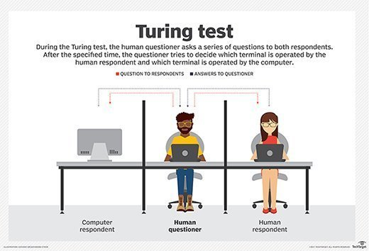

Stanley Kubrick's *2001: A Space Odyssey* presented one of the world's earliest AI robots, the *HAL 9000*. HAL can recognize speech, understand natural language and even win chess games. Now a part of Carnegie Mellon University's [Hall of Fame](http://www.robothalloffame.org/inductees/03inductees/hal.html), HAL still inspires scientists to look for ways to duplicate its 1960s-imagined capabilities.

In the 1950s, George C. Devil invented a reprogrammable manipulator -- Unmated. Engineer Joseph Eagleburger acquired Devil’s robot patent and converted his design into the world's first industrial robot*.* He eventually earned the label: The Father of Robotics.

In 1966, MIT developed one of the [earliest AI-based bots, ELIZA](https://www.techtarget.com/searchenterpriseai/feature/AI-and-chatbots-Conversational-app-platforms-are-maturing), while [SRI International](https://www.techtarget.com/whatis/definition/SRI-International-SRI?_gl=1*48666m*_ga*MTEzNjc2NDgyMC4xNjIwNjg1MjQy*_ga_RRBYR9CGB9*MTYyMDY4NTI0Mi4xLjAuMTYyMDY4NTI0Mi4w&_ga=2.218799515.321333293.1620685242-1136764820.1620685242) later designed Shaky, a self-directed robot, for specialized industrial applications. By the early 70s, scientists had successfully integrated bots into medicine with MYCIN to help identify bacteria and INTERNIST-1 computer-based diagnostic tool. In the 1980s, [ALVINN](https://ntrl.ntis.gov/NTRL/dashboard/searchResults/titleDetail/ADA218975.xhtml), the robotics tech that powers today's self-driving cars was developed.

By the 1990s, consumer-facing bots appeared as computer games like Tamagotchi. Post 2000, interest in robots and robotics exploded with the release of Smarter Child, a [programmed bot](https://www.techtarget.com/searchmobilecomputing/tip/Understand-chatbot-use-cases-and-features-for-business) within AOL Instant Messenger that's now considered the forerunner AI to Apple's [Siri](https://www.techtarget.com/searchmobilecomputing/definition/Siri).

In the early 2000s [Packo](https://www.flir.com/products/packbot/), a military robot, and [Stanley](https://americanhistory.si.edu/collections/search/object/nmah_1377824), a vehicular bot*,*were both invented. Notably, Packo played an important role in the aftermath of the 9/11 attacks, as first responders sent the robot into the rubble to search for victims and assess the structural integrity of the debris. Packo sent back pictures from hard-to-reach places, helping with the rescue effort.

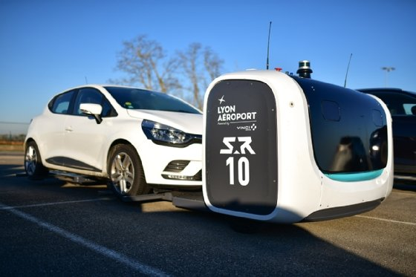

The Packo inspired a new era of robotics, accelerating the development of more advanced, autonomous machines that now help in areas such as the following:

* disaster management
* law enforcement
* weather forecasts
* residential hygiene
* military reconnaissance

Later, household robots like Roomba and AI-based robots like Siri and Alexa paved the way for robots in people's everyday lives, furthering their potential.

Today's robots can carry out a number of complex tasks that would have been written off as science fiction even half a century ago. Smart, intelligent robots are now collaborating with humans and helping to solve problems that looked unsolvable in the past.

Question 2: what are the three main components of a robot

# **What Are the Main Components of A ROBOT? A Research Based Study**

Robots and automation are becoming significant parts of our daily lives. Now not only the robots are just using it to make an impression.

You will find them everywhere, but how are they functioning? First, you have to know what are the components of a robot.

Then you will understand how they are working like humans.

What you are thinking, you are surrounded by them, but how?

Yes, from your favorite home cleaning Roomba robots to plant robotic handles working on the packaging lines. Everything is part of robotics and runs based on programming.

Let’s see first what is the actual answer for ‘what is Robots.’

## **What Is A Robot?**

Robots are automatically operated machines, which can be fully automatic or semi-automatic. The goal of inventing robots is pretty simple. Wherever you want to [replace human efforts](https://www.technetdeals.com/can-artificial-intelligence-replace-human-intelligence/), you have to use robots. These robots function like humans, but these are the combinations of engineering declines.

You can complete human-like works; therefore, Robots do not have the mind and do not understand human feelings. As a result, the components of robots are very similar to any machine and computer. And the CPU is the central part of all the components.

Now let’s move on to the next part and see ‘what are the main components of a robot’.

## **What Are Major Components of A Robot?**

Every robot’s functions and objectives are different. Based on these objectives, the robots are designed in different ways. But the five components are always the same.

**What are the 5 main components of a robot, “Control system Sensors Actuators Power Supply End Effectors”?**

Yes, these five components are always the same and compulsory parts of the robots. But apart from these five, the programming parts also make the robots unique. So you have to add this component to the list.

George C. Devil was the first creator of [Robotics](https://www.technetdeals.com/robotics/). He was an inventor from Louisville, Kentucky. His innovations were called a programmable manipulator called Unmated. From that day to today, the 5 main components of ROBOTs are the same.

### ****1. CPU****

CPUs are the central components of a robot and in any smart computer technology. This is the brain of the robot. The CPU is the part that keeps everything in the right place and provides the proper feedback.

The functions and the programs are stored here. First, robots are taking the environmental data by using sensors. Then, through the programming, it does the appropriate actions.

CPUs function like the human brain. Data is coming through the sensors, and information is already stored in the memory. CPU interprets the signals, and robots are involved in the acts accordingly.

### ****2. Sensors****

Sensors are another essential part of the components of a robot. These sensors are the powerhouse of Robots. They are working as the human eyes and ears. However, these sensors work very differently.

Depending on the goals of Robots, the designers have to install the sensors. These sensors take the information from the surroundings. And supply this information to the CPU. CPU, based on these instructions, do the actions.

**Here are the names of a few sensors:**

* Light and sound sensors.
* Temperature and Colour sensors.
* Contact sensors.
* Distance and gap sensors.
* Pressure parameter sensors.
* Positioning understanding sensors.

Each of these sensors works differently. Through the positioning of GPS sensors and magnetic compass, the robots will understand the actual distances and the approximate location of the robots. In industrial use, the Pressure parameter sensors are more prominent.

### ****3. Actuators****

Actuators are the components of a robot. If the sensors of the eyes and ears are not functioning like muscles. Then actuators are more working as a small motor. These small motors are directly attached to the robotic structures. And it facilitates the required movement.

Electric actuators are more like research-associated works. Still, now multiple projects are in the pipeline. But these types of functions are improving control and reducing environmental hazards.

**Here are three types of Robot Actuators:**

* **Hydraulic Actuators:**It requires oil to streamline the required movement.
* **Electric Actuators:** Uses electric power for magnifying and facilitating movement.
* **Pneumatic Actuators:** Uses air to stimulate movement.

Among these three types of actuators, the hydraulic ones are exclusively compatible with industrial use and requirements. Pneumatic Actuators are used as cost-effective solutions for robot manufacturing. The Electric Actuators are the smartest ones and perfect for complex programming works.

### ****4. End-Effectors****

The end effectors are a very crucial part of the components of a robot. These functions determine how the robots communicate with the environment. For example, factory robots are programmed to do welding torches, rivet guns, and paint sprays. These all actions go through the quality checking of end effectors.

For example, usually, mobile robots are programmed to lift objects. From simple to complex, every work has to end effectors. Even the latest technology is inventing a robotic hand with cameras. At the end of every robotic hand, the designers add a camera to monitor the whole process.

All of these new designs are keeping the system intact and improving the accuracy level. For the safety and security issues, all of these factors are outstanding.

### ****5. Power Supply****

Food is giving power to every human being. We all consume foods to improve our stability and keep our bodies in functioning mode. And Robots are not exceptional ones. The components of a robot are function when the power supply is enough.

Some robots are receiving electrical power from the power supply. Some are working with battery powers. But without suitable sources of energy, Robots cannot perform and do the task.

Many Robots are also available in the market, which has power-saving features.

Bright designs minimize the mechanical motions. Others are using green energy sources.

### ****6. Programming****

Programming is not part of the physical and hardware components of a robot. But it is an integral part of the robot’s functions. So the programs are installed in the robots. And on the foundation of the established procedures.

The programs are designed with logic and functions. Robots contain a bulk of programs and designs. And all of these programs are stored inside the robots. The environment data and tasks are analyzed based on these functions.

Programmers create these programs. And every program is running based on different logics. So even some robots find it convenient to find another way to complete the process.

## **Frequently Asked Questions About Robots:**

### ****1. What Are the Primary Mechanical Components of A Robot?****

**The primary mechanical components of robots are:**

* Locomotion System.
* Arms and metal body.
* Controller and power supply unit.
* [Actuator system](http://www.ae.utexas.edu/courses/ase463q/design_pages/summer02/activewing/page011.html).
* The auto sensor system.
* End effector.

### ****2. What Is the Full Form of Robot?****

The robot is the short form of the IEEE International Conference on Robotics and Automation.

### ****3. What Are The 8 Components of Robots?****

**The 8 main Components of Robots are:**

* Actuation.
* DC Motor.
* Stepper Engine.
* [Piezo Motors](https://patents.google.com/patent/US6373170).
* Air Muscles.
* Electroactive high magnetic polymers.
* Carbon Elastic nanotubes with better elasticity.
* Manipulation.

## **Wrapping Up**

Components of a robot all work in different ways. But these six are the main components of any robot. Maybe the programming parts do not belong in the hardware component category. But all of these components are pretty essential.

What is your idea about robotics and designs? Let us know through the comment sections. Also, if you have any innovative robotics design ideas, share your ideas in the comment sections.

Question 3: what are the main types of robots based on their applications

# **Types of robots: classification, applications and examples**

Robots can be classified in keeping with their chronology and function and the segment that they focus on. They currently have numerous areas of action, including industry, education, health and the domestic unit

The Spanish Royal Academy defines a robot as a “programmable electronic machine or device capable of handling objects and performing different operations”. In short, they’re machines that perform a job or action. Depending on their functions and chronology and the sector they operate in, we can distinguish several types of robots.

## **Types of robots by chronology**

In this case, up to five types of robots can be distinguished, in keeping with the stages that robotics has gone through until the present day.

### First generation: robot manipulators

These can pick up and move objects but they have very restricted movements.

### Second generation: learning robots

This gather information from the environment to make more complex movements.

### Third generation: reprogrammable robots

These are equipped with sensors and they use programming languages to vary their functions in keeping with the needs of any given moment.

### Fourth generation: mobile robots

The first intelligent robots capable of interpreting the environment in real time appear in the fourth generation.

### Fifth generation: robots with artificial intelligence

This is the stage that’s currently under development. They’re intended to mimic human beings and they’re autonomous.

## **Types of robots depending on their mobility**

Another highly interesting way of classifying robots is related to their mobility. Depending on their performance and capacity for movement and decision-making, they can be distinguished as follows:

* Articulated robots or robotic arms: These have very low capacity, but they’re excellent partners for moving products, handling tools, packaging, etc.
* Automated guided vehicles (AGVs): these move along a pre-defined track and they usually require human supervision.
* Autonomous mobile robots: what are known as AMRs can move and make decisions on their own, practically in real time. They incorporate sensors and on-board processing equipment to carry out their functions.
* Humanoids: usually a type of AMR, they have human forms and they can perform functions like people.
* Cabot’s: these are designed for the purpose of working alongside with humans, helping with dangerous and repetitive tasks.

## **Types of robots by function or sector**

The second classification used for robots is based on their functions and the environment in which they operate, in other words, the sector they’re designed for, such as industry, livestock breeding, education, health, logistics, etc.

Thus, we can chiefly find military, industrial, service, educational, research, medical and domestic robots, although the list could be as long as the possibilities for their use that exist. Each of them has a specific function. The main ones are outlined below:

* **Industrial robots:**These types of robots have a clear focus on the production line and they carry out routine and repetitive activities. For example, they may be tasked with categorizing products at a warehouse or participating in an assembly line by moving products along it.
* **Domestic robots:**These help with cleaning tasks and watching over the house. This group includes vacuum-cleaning robots, lawn-mowing robots, kitchen robots that prepare a recipe from start to finish and connected security cameras.
* **Educational robots:**This group may include machines intended for cognitive development or the learning of a subject. Such as robotics kits for children.
* **Military robots:** As for military robots, they’re responsible for supporting armies during certain operations, such as transporting equipment and helping to detect the presence of explosives.
* **Medical robots:**These can provide support for the health sector, e.g. in order to assist people with reduced mobility, move machinery and medicines and even participate in surgical procedures

Question 4: give 3 examples of sensors that helps a robot understand it environment

# Sensors in Robotics – 7 Common Sensors Used in Robots

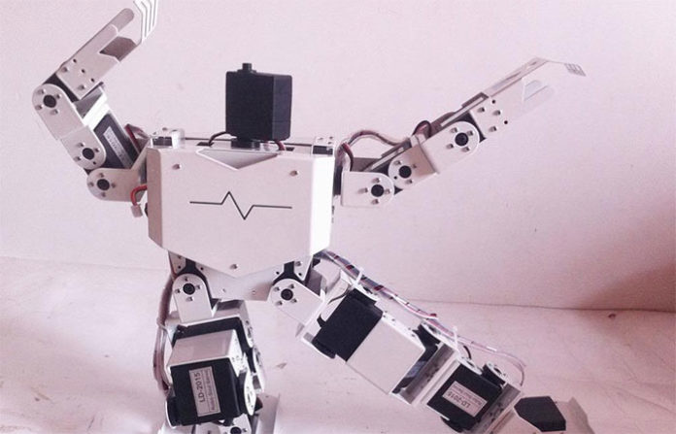

Sensor is a window for a robot to the environment. [Sensors](https://en.wikipedia.org/wiki/Robotic_sensors) allow robots to understand and measure the geometric and physical properties of objects in their [surrounding environment](https://roboticsbiz.com/top-14-best-programmable-robot-kits-for-education/), such as position, orientation, velocity, acceleration, distance, size, force, moment, temperature, luminance, weight, etc.

Sensors are generally classified into two groups: internal sensors and external sensors. Internal sensors such as its position sensor, velocity sensor, acceleration sensors, motor torque sensor, etc.

obtain the information about the robot itself, while external sensors such as cameras, range sensors (IR sensor, laser range finder, and ultrasonic sensor) contact and [proximity sensors](https://roboticsbiz.com/the-benefits-of-using-drones-for-construction-projects/) (photodiode, IR detector, RFID, touch, etc.) and force sensors gather the information in the surrounding environment.

Sensors are defined by various properties that describe their capabilities:

* Sensitivity (change of output and change of input)
* Linearity (constancy of output and input)
* Response Time (time required for a change in input to force a change in the output)
* Measurement/Dynamic range (difference between minimum and maximum)
* Accuracy (difference between measured & actual)
* Repeatability (difference between repeated measures)
* Resolution (smallest observable increment)
* Bandwidth (result of high resolution or cycle time)

Sensors are used in robots for a variety of tasks. A greater use of sensors, therefore, is highly essential to avoid uncertainty and achieve higher productivity. In this post, we will briefly discuss seven common sensors used in robots.

## **1. Light Sensor**

A light sensor detects light and creates a difference in voltage. A robot’s vision system has a computer-controlled camera that allows the robot to see and adjust its movements accordingly. The two primary light sensors in robots are Photo resistor and Photovoltaic cells. Other light sensors like phototubes, phototransistors, CCDs, etc. are rarely used.

**a) A photoresist or** is a type of resistor whose resistance varies with light intensity changes; more light leads to less resistance, and less light leads to more resistance. They can be easily implemented in light-dependent robots.

**b) Photovoltaic cells** convert solar radiation into electricity. This is especially helpful when planning a solar robot. While the photovoltaic cell is considered as an energy source, a smart implementation combined with transistors and capacitors can convert this into a sensor.

**2D & 3D Vision:** A standard 2D machine vision image is flat, calibrated to measure length and width, but does not provide any height information.

3D vision allows a robot to detect the orientation of a part that needs handling more effectively, even if the location and position of the components vary. A 3D vision system can accurately guide a robotic arm during assembly, while a robotic arm can provide multiple viewing angles for critical assembly inspection.

## **2. Sound Sensor**

Sound sensors are generally a microphone used to detect the equivalent voltage of sound and return. The sound it receives can be navigated by a simple robot. Imagine a robot turning right to a pulpit, turning left for two palpitations. Complex robots may use the same microphone for voice recognition.

Sound sensors are not as easy as light sensors because sound sensors generate a minimal voltage difference which should be amplified to produce a measurable change in voltage. Voice systems also use robots with voice commands. This is useful if the trainer has to handle other objects when training robots.

## **3. Proximity Sensor**

The nearby object can be detected by a proximity sensor without physical contact. The transmitter transmits electromagnetic radiation in the adjacent sensor and receives and analyzes the interruption feedback signal.

Thus, the amount of light received in the area can be used to detect the presence of nearby objects. The sensors provide a collision avoidance method for the robot.

There are various types of proximity sensors, and only a few of them are usually used in robots.

**Infrared (IR) transceiver:** An IR LED transmits an IR light beam that reflects the light captured by an IR recipient when an obstacle is found.

**Ultrasound Sensor:** These sensors generate sound waves at high frequencies; the received echo indicates an object is interrupted. Ultrasound sensors can also be used for distance measurement.

**Photo resistor:** Photo resistor is a light sensor, but it can still be utilized as a sensor of proximity. If an object approaches the sensor, the number of light changes, which changes the resistance of the Photo resistor. This is detectable and process able.

## **4. Tactile Sensors**

Tactile Sensor is a device specifying an object’s contact. Often used in everyday objects such as elevator buttons and lamps, which dim or brighten by touching the base, a tactile sensor allows the robot to touch and feel.

These sensors are used to measure applications and gently interact with the environment. It can be sorted into two principal types: Touch Sensor and Force Sensor.

1. **Touch Sensor or Contact Sensor:** Touch Sensor is capable of sensing and detecting sensor and object touch. Some of the commonly used simple devices are micro-switches, limit switches, etc.
2. These sensors are mostly used for robots to avoid obstacles. When these sensors hit an obstacle, it triggers a task for the robot, which can be reversed, turned, switched on, stopped, etc.
3. **Force Sensor:** Force sensor is included in calculating the forces of several functions, such as machine loading & unloading, material handling, and so on, performed by a robot.
4. This sensor will also be a better assembly process to check problems.

## **5. Temperature Sensor**

Temperature sensors are used to detect the surrounding temperature change. It is based on the principle of voltage difference change for a temperature change; this voltage change will provide the surrounding temperature equivalent. Temperature sensing applications include air temperature, surface temperature, immersion temperature.

## **6. Navigation and Positioning Sensors**

Positioning sensors are used to approximate the position of a robot. The usual positioning sensor is a GPS (Global Positioning System). Satellites orbiting our Earth transmit signals, and a robot receiver acquires and processes these signals.

Use the processed information to determine a robot’s approximate position and velocity.

Digital Magnetic Compass provides directional measurements using the Earth’s magnetic field that guides your robot to reach its destination.

Compared to GPS modules, these sensors are cheap, but a compass works best when you need both positional feedback and navigation.

Another method called location refers to the task of automatically determining a robot’s location based on external elements such as natural and artificially placed landmarks such as doors, windows, walls, etc.

## **7. Acceleration Sensor**

An accelerometer is a device for measuring acceleration and tilt. The two types of forces affect an accelerometer:

a) Static Force — the frictional force between any two objects. By measuring this gravity, we can determine how much robot tilts. This measurement is useful in balancing robot or determining whether a robot is driving on a flat or uphill surface.

B) Dynamic Force — The acceleration required to move an object. Measuring dynamic force using an accelerometer tells the speed/speed at which a robot moves.